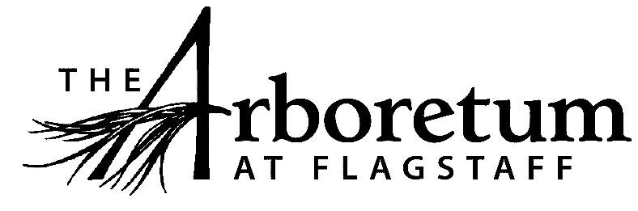

Education Assistant

Classification​
Non-Exempt
Reports to
Education Programs Manager
Date
October 10, 2019
JOB DESCRIPTION

Summary/Objective
This position is responsible for assisting the Education Programs Manager with all tasks. These tasks may include school field trip leading and scheduling, summer camp staff assistance, and docent tours. Additionally, this position will be in charge of training and scheduling volunteer Segway tours and occasionally leading said tours.
Essential Functions
Reasonable accommodations may be made to enable individuals with disabilities to perform the essential functions.
Assist the Education Programs Manager with:
- Booking and leading school field trips;
- Training docents and other volunteers in field trip leadership;
- Docent volunteer scheduling;
- Booking and leading non-school tours;
- Summer camp staff assistance;
- Planning volunteer appreciation events;
- Communicating with volunteers through a volunteer e-newsletter;
- Participate in off-site educational outreach events;
- Conduct, schedule, and train docents/volunteers for Segway tours. Additionally, since this is a new attraction, the Education Assistant will need to help promote the attraction.
- As a public venue that focuses on excellent guest experiences all employees are expected to engage the public in a friendly manner, answer questions, and exhibit professionalism while representing The Arboretum.
- All other duties as assigned and/or needed to keep The Arboretum running efficiently.

Competencies
- Skilled with Microsoft Office suite (Word, Excel, Power Point) and Google docs and Sheets
- Strong organizational, scheduling and time management skills
- Ability to present in front of others in an engaging manner
- Demonstrate ability to supervise and train professionally
- Ability to work well with others with diverse backgrounds and skills/education
- Ability to create a positive and fun atmosphere
- Ability to work in fast paced, challenging environment
- Ability to demonstrate initiative and establish priorities

Supervisory Responsibility
This position has no direct paid staff supervisory responsibilities but helps supervise the entire volunteer force and any departmental interns.
Work Environment
This job may work indoors or outside based upon program and volunteer needs and during various parts of the day or night. This role interacts with others on a regular basis and routinely uses office equipment of all kinds to accomplish the job.
The Arboretum is located down 3 miles of dirt road that can be wash boarded, muddy, potholed and very challenging during inclement weather and between road grading. Thus, must have reliable transportation.
Physical Demands
The physical demands described here are representative of those that must be met by an employee to successfully perform the essential functions of this job.
While performing the duties of this job, the employee is regularly required to talk or hear. The employee frequently is required to sit, use hands to finger, handle or feel; use a keyboard, and reach with hands and arms. This role is occasionally required to walk, stand, and participate in events outside at various days and times. The employee must be able to occasionally lift and/or move objects up to 40 pounds.
Position Type and Expected Hours of Work
This is a seasonal, 25 hours a week seasonal position. This position is from April 1st through October 31st. Days and hours of work vary depending on program needs.
Travel
Many programs require travel throughout the City.
Required Education and Experience
- High school diploma
- Minimum of 6 months experience working with school age children

Preferred Education and Experience
- Completion of some college, (bachelor’s preferred)
- Experience in education, natural science, environmental education or environmental studies
- Previous work with volunteers
Additional Eligibility Qualifications
- Strong interpersonal and verbal communication skills
- Possess a fun, vibrant personality who is committed to the visitor experience
- Ability to work independently
- Interest in environmental education

Work Authorization/Security Clearance
- Must pass a background check and hold a valid driver’s license.
- Must obtain a food handler’s permit through Coconino County.

AAP/EEO Statement
The Arboretum is an equal opportunity employer committed to applying the principles of applicable state and federal anti-discrimination laws to give equal opportunity for all persons employed or seeking employment without regard to race, age, sex, national origin, religion, color, sexual preference, or disability except in the case of a bona-fide occupational qualification.

In accordance with the applicable law, The Arboretum makes reasonable accommodations for qualified individuals with known disabilities unless doing so would result in an undue hardship. This policy governs all aspects of employment, including selection, job assignment, compensation, discipline, termination and access to benefits and training. The Arboretum operates within the principles of equal employment opportunity guidelines as set forth in applicable federal and state law.

Other Duties
Please note this job description is not designed to cover or contain a comprehensive listing of activities, duties or responsibilities that are required of the employee for this job. Duties, responsibilities and activities may change at any time with or without notice.
Signatures

This job description has been approved by all levels of management:
Manager_______________________________________________
HR____________________________________________________
Employee signature below constitutes employee's understanding of the requirements, essential functions and duties of the position.
Employee____________________​_________ Date_____________

