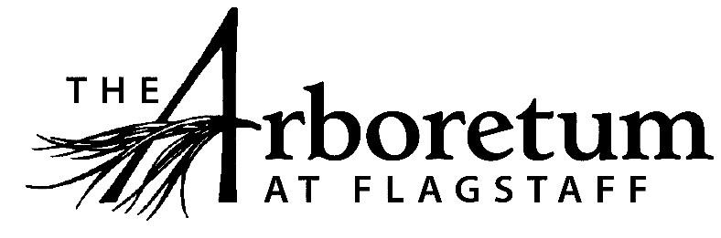

Grounds Supervisor

Classification​
Non-Exempt
Reports to
Facilities & Grounds Manager
Date
January 25, 2021
JOB DESCRIPTION
Summary/Objective
This position is responsible for maintaining The Arboretum grounds including cultivated gardens and natural areas.
Essential Functions
Reasonable accommodations may be made to enable individuals with disabilities to perform the essential functions.
- Direct the maintenance of existing gardens through planting, weeding, pruning, irrigation and hardscape maintenance;
- Pest and disease control;
- Fertilization and mulching;
- Work with the Horticulturist to develop plant material for use in the gardens and in planters;
- Maintain grounds equipment and tools;
- Support educational activities;
- Plan volunteer activities and direct volunteer groups
- Assist with annual plant sales and other events as needed;
- Assist with the maintenance of exterior infrastructures such as roads, trails, fences, benches, picnic tables, signs, parking lot, etc.
- As a public venue that focuses on excellent guest experiences all employees are expected to engage the public in a friendly manner, answer questions, and exhibit professionalism while representing The Arboretum.
- All other duties as assigned and/or needed to keep The Arboretum running efficiently.
Competencies
- Strong verbal and written communication skills
- Ability to prioritize time sensitive tasks
- Ability to lead grounds activities with groups of volunteers, interns and/or staff
- Ability to work independently, as well as part of a team
- Knowledge of plant care
Supervisory Responsibility
This position supervises and trains Grounds Assistants and volunteers.
Work Environment
This job operates primarily outside, in all types of weather.
The Arboretum is located down 3 miles of dirt road that can be wash boarded, muddy, potholed and very challenging during inclement weather and between road grading. Thus, must have reliable transportation.
Physical Demands
The physical demands described here are representative of those that must be met by an employee to successfully perform the essential functions of this job.
While performing the duties of this job, the employee is regularly required to lift up to 60 pounds; walk, stoop, raise arms above head, dig and shovel various materials; operate motorized and hand powered equipment; and work in all types of weather.
Position Type and Expected Hours of Work
This is a full time (35 hours per week), seasonal position. The season for this position is March 1 through November 15. Days and hours of work vary depending on the needs of the business, but primarily are Monday through Friday. Some weekend work is required.
Travel
This position does not require travel.
Required Education and Experience
- Three or more years of experience in landscaping, gardening, plant care or related field
Preferred Education and Experience
- B.Sc. in plant sciences
- Knowledge of native & cultivar plants of the Colorado Plateau
- Knowledge of plant taxonomy and ecology
- Knowledge of basic irrigation operation and maintenance
- Experience with leading volunteer groups
Additional Eligibility Qualifications
None required for this position.
Work Authorization/Security Clearance
Must pass a background check and hold a valid driver’s license.
AAP/EEO Statement
The Arboretum is an equal opportunity employer committed to applying the principles of applicable state and federal anti-discrimination laws to give equal opportunity for all persons employed or seeking employment without regard to race, age, sex, national origin, religion, color, sexual preference, or disability except in the case of a bona-fide occupational qualification.

In accordance with the applicable law, The Arboretum makes reasonable accommodations for qualified individuals with known disabilities unless doing so would result in an undue hardship. This policy governs all aspects of employment, including selection, job assignment, compensation, discipline, termination and access to benefits and training. The Arboretum operates within the principles of equal employment opportunity guidelines as set forth in applicable federal and state law.
Other Duties
Please note this job description is not designed to cover or contain a comprehensive listing of activities, duties or responsibilities that are required of the employee for this job. Duties, responsibilities and activities may change at any time with or without notice.

Signatures
This job description has been approved by all levels of management:
Manager_______________________________________________
HR____________________________________________________
Employee signature below constitutes employee's understanding of the requirements, essential functions and duties of the position.
Employee____________________​_________ Date_____________

