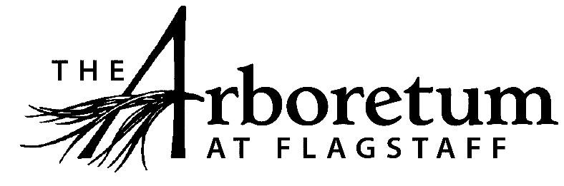

**Custodian**

Page Content

**Classification​**

Non-exempt

**Reports to**Facilities Manager

**Date**  
  
March 10, 2021

**JOB DESCRIPTION**

**Summary/Objective**

This position assists the Facilities Manager in Arboretum custodial duties on the grounds and in all of the facilities.

**Essential Functions**

Reasonable accommodations may be made to enable individuals with disabilities to perform the essential functions.

* Custodial Duties
  + Responsible for core cleaning of main public restrooms, indoor rental spaces, Visitor Center and Exhibit Room, staff restrooms and offices and other public areas. Examples of duties are listed below;
    - Vacuuming and dusting
    - Cleaning windows
    - Making sure soap and sanitizer dispensers are full; toilet paper and paper towels are stocked
    - Mopping floors in restrooms
    - Cleaning sinks and toilets
  + Empties grounds and building trash and recycling on a regular basis (not responsible for wedding trash/recycling), including three “doggy doo” stations.
  + Assists with event set-up and clean-up

All other duties as assigned and/or needed to keep The Arboretum running efficiently.

**Competencies**

* Superior organizational skills
* The ability to work within a team comprised of a variety of disciplines and people
* Mechanically inclined
* Extremely conscious of safety protocols
* Able to work independently
* Strong communication skills
* Flexible schedule

**Supervisory Responsibility**

This position has no direct staff supervisory responsibilities but does supervise volunteers as needed.

**Work Environment**

This role works indoors and outdoors and various types of weather and times of day or night to meet the needs of this role. This role operates mechanical devices as needed. This role routinely uses standard office equipment such as computers, phones, photocopiers, filing cabinets and fax machines to accomplish administrative tasks.

The Arboretum is located down 3 miles of dirt road that can be wash boarded, muddy, potholed and very challenging during inclement weather and between road grading. Thus, must have reliable transportation.

As a public venue that focuses on excellent guest experiences all employees are expected to engage the public in a friendly manner, answer questions, and exhibit professionalism while representing The Arboretum.

**Physical Demands**

The physical demands described here are representative of those that must be met by an employee to successfully perform the essential functions of this job.

While performing the duties of this job, the employee is regularly required to talk or hear. The employee frequently is required to stand; walk; use hands to finger, handle or feel; and reach with hands and arms. The employee must frequently lift and/or move objects up to 10 pounds and occasionally lift and/or move objects up to 60 pounds.

**Position Type and Expected Hours of Work**

This is a seasonal (April through October), part-time (up to 30 hours/week) position. Days and hours of work are Flexible. Evening and weekend work frequently may be required as job duties demand.

**Travel**

Travel is not required for this position.

**Required Education and Experience**

* One year or more of successful work experience in this or a related field.

**Preferred Education and Experience**

* Cleaning, equipment, and safety-related certifications

**Additional Eligibility Qualifications**

Must have valid AZ Driver’s License and have a trust-worthy vehicle

**Work Authorization/Security Clearance**

Must be able to pass a background check.

**AAP/EEO Statement**

The Arboretum is an equal opportunity employer committed to applying the principles of applicable state and federal anti-discrimination laws to give equal opportunity for all persons employed or seeking employment without regard to race, age, sex, national origin, religion, color, sexual preference, or disability except in the case of a bona-fide occupational qualification.

In accordance with the applicable law, The Arboretum makes reasonable accommodations for qualified individuals with known disabilities unless doing so would result in an undue hardship. This policy governs all aspects of employment, including selection, job assignment, compensation, discipline, termination and access to benefits and training. The Arboretum operates within the principles of equal employment opportunity guidelines as set forth in applicable federal and state law.

**Other Duties**

Please note this job description is not designed to cover or contain a comprehensive listing of activities, duties or responsibilities that are required of the employee for this job. Duties, responsibilities and activities may change at any time with or without notice.

**Signatures**This job description has been approved by all levels of management:

Manager_______________________________________________

HR____________________________________________________

Employee signature below constitutes employee's understanding of the requirements, essential functions and duties of the position.

Employee____________________​_________ Date_____________

