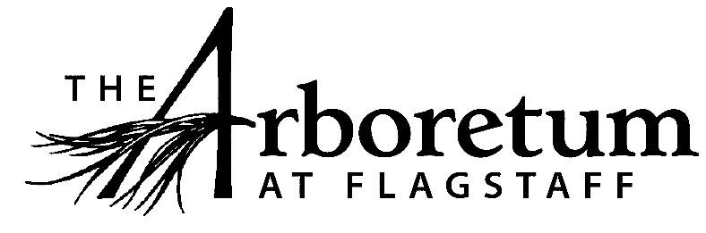

Visitor Center Host

Classification​
Non-Exempt
Reports to
Visitor Center & Membership Coordinator
Date
April 8, 2021
JOB DESCRIPTION
Summary/Objective
The Visitor Center Host is responsible for creating positive experiences during all interactions. These interactions are in person, via phone, or through online systems with members, prospective members, consignment artists, volunteers and the general public. This role performs admittance processes, membership enrollments, and gift shop sales. A cheerful, professional, and helpful personality is necessary to our visitor’s experience.
Essential Functions
Reasonable accommodations may be made to enable individuals with disabilities to perform the essential functions.
- Gift Shop
  - During all initial interactions, greet visitors in a friendly and positive manner;
  - Provide relevant information including contact information, hours of operation, event information and membership information in a clear and concise manner;
  - Thank existing members for their membership;
  - Encourage non-members to consider joining The Arboretum and encourage existing members to renew, or purchase gift memberships for others;
  - Provide exiting guests with a positive departure and an invitation to return; Provide phone and online guests with an invitation to visit The Arboretum
  - Perform customer service duties supporting the main desk in the visitor center;
  - Collect payments from daily visitors, membership renewals, new memberships, events and gift shop sales
    - Use of the point-of sale system for gift shop sales
  - Answer questions about The Arboretum, gift shop items and other related items in-person, via phone, or electronic methods;
  - Seek assistance from others if unable to answer a question or address a concern;
  - Keep the gift shop organized and appealing which includes straightening items, dusting, sweeping front walk and back patio, and other cleaning activities;
  - Manage the artist catalog to track inventory and sales;
  - Ensure the front desk and shop are stocked with appropriate materials (membership brochures, maps, snacks, etc.);
  - Create and maintain a variety of administrative spreadsheets and documents to support smooth operations;
  - Perform other visitor center duties as assigned

- Events
- Visitor’s Center hosts are required to work events. This includes, but is not limited to: set up/take down of chairs, tables and pop up tents, working the will call and day of ticket sales tables, occasionally required to take payments in the garden using PayPalHere (Summer Plant Sale and Summer Concert Series) or other activities as assigned

- As a public venue that focuses on excellent guest experiences all employees are expected to engage the public in a friendly manner, answer questions, and exhibit professionalism while representing The Arboretum.
- All other duties as assigned and/or needed to keep the Arboretum running efficiently.
Competencies
- Microsoft Word, Excel and Google Docs experience required
- Prompt, dependable and detail-oriented with ability to demonstrate initiative, establish priorities, work independently and as part of a team
- Ability to manage cash and customer payments with a high level of accuracy
- Must be skilled at positive and friendly human interactions
Supervisory Responsibility
This position has no direct staff supervisory responsibilities but may work with volunteers or interns on a regular basis.
Work Environment
This job operates in a professional office environment, off site venues and outside event areas in various weather conditions. This role routinely uses standard office equipment such as computers, phones, photocopiers, filing cabinets and fax machines.
The Arboretum is located down 3 miles of dirt road that can be wash boarded, muddy, potholed and very challenging during inclement weather and between road grading. Thus, must have reliable transportation.Physical Demands
The physical demands described here are representative of those that must be met by an employee to successfully perform the essential functions of this job.
While performing the duties of this job, the employee is regularly required to talk or hear. The employee frequently is required to stand; walk; use hands to finger, handle or feel; and reach with hands and arms. The employee must frequently lift and/or move objects up to 10 pounds and occasionally lift and/or move objects up to 25 pounds.
Position Type and Expected Hours of Work
This is a part-time seasonal position. Hours are 20-30 per week and the employee must be able to work weekdays, weekends and some holidays.
Travel
There is no travel required for this position.

Required Education and Experience
Must have retail and cash handling experience.

Preferred Education and Experience
High school Diploma and or G.E.D.

Additional Eligibility Qualifications
- Possess a fun, vibrant personality who is committed to the visitor experience.
Work Authorization/Security Clearance
- Must pass a background check and hold a valid driver’s license.
- Must obtain a food handler’s permit through Coconino County.
AAP/EEO Statement
The Arboretum is an equal opportunity employer committed to applying the principles of applicable state and federal anti-discrimination laws to give equal opportunity for all persons employed or seeking employment without regard to race, age, sex, national origin, religion, color, sexual preference, or disability except in the case of a bona-fide occupational qualification.

In accordance with the applicable law, The Arboretum makes reasonable accommodations for qualified individuals with known disabilities unless doing so would result in an undue hardship. This policy governs all aspects of employment, including selection, job assignment, compensation, discipline, termination and access to benefits and training. The Arboretum operates within the principles of equal employment opportunity guidelines as set forth in applicable federal and state law.
Other Duties
Please note this job description is not designed to cover or contain a comprehensive listing of activities, duties or responsibilities that are required of the employee for this job. Duties, responsibilities and activities may change at any time with or without notice.
Signatures
This job description has been approved by all levels of management:
Manager_______________________________________________
HR____________________________________________________
Employee signature below constitutes employee's understanding of the requirements, essential functions and duties of the position.
Employee____________________​_________ Date_____________

