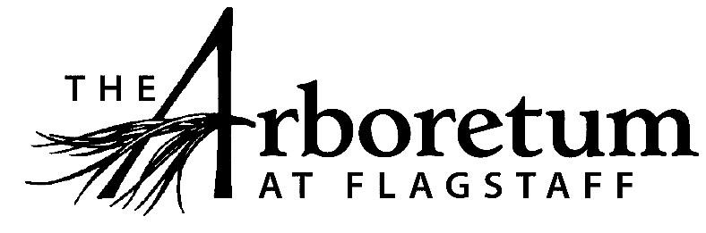

Facilities Manager

Classification​
Non-Exempt
Reports to
Executive Director
Date
April 6, 2021
JOB DESCRIPTION
Summary/Objective
This position is responsible for the appropriate maintenance of all structures, facilities, vehicles and equipment on The Arboretum’s grounds. In addition, the Facilities Manager serves as the primary rental property manager, responsible for seeing to tenants needs and keeping rental spaces occupied, for The Arboretum. The Facilities Manager supervises the Custodian position and works collaboratively with other Arboretum staff to ensure positive visitor experiences. This role also supports the safety functions for the organization and assists the Executive Director with inspections and prioritizing maintenance expenditures.
Essential Functions
Reasonable accommodations may be made to enable individuals with disabilities to perform the essential functions.
- Facilities Maintenance Duties
  - Performs core facility maintenance duties in compliance with The Arboretum, state and federal safety guidelines;
    - Examples of the core duties include, but are not limited to: plumbing, electrical, HVAC, carpentry, painting, janitorial and basic building repair work
    - Maintains The Arboretum’s tools and support equipment
    - Creates and follows maintenance plans for all assigned buildings and equipment
    - Performs safety walk-throughs of facilities and grounds and coordinates fire extinguisher re-charging
    - Makes directional/event signs as needed
  - Prepares maintenance records and other required record keeping for audits, compliance needs, and contractors;
  - Performs locksmith duties or works with appropriate contractors;
  - Performs other maintenance duties as assigned for events, new projects or similar;
  - Operates snow plow equipment and addresses weather concerns or changes appropriately;
  - Establishes and follows a checklist of preventative and required services that include but are not limited to: Outsourced vendor duties (septic system, chimney sweep);
  - Recommends and manages The Arboretum’s approved facilities budget;
  - Serves as supervisor to and liaison between private contractors and The Arboretum;
  - Supports Arboretum events in regards to facilities set up, preparation, and breakdown based upon the specific needs of the event;

- Vehicle and Equipment Maintenance
  - Ensures vehicles are in working order and performs regular basic maintenance;
  - Collaborates with the Finance Manager and Executive Director to ensure vehicles are properly licensed and recommends purchases related to vehicle needs

- Personnel Management
  - Supervises support staff when budget allows for said staff or volunteers;
    - Provides appropriate training and supervision
  - Organizes and inventories facilities equipment and materials;
  - Manages and trains Custodian position;
  - Orders custodial supplies.

- As a public venue that focuses on excellent guest experiences all employees are expected to engage the public in a friendly manner, answer questions, and exhibit professionalism while representing The Arboretum.

- All other duties as assigned and/or needed to keep The Arboretum running efficiently.
Competencies
- Superior organizational and communication skills
- The ability to work within a team comprised of a variety of disciplines and people
- Mechanically inclined
- Extremely conscious of safety protocols
- Able to work independently
- Ability to perform routine paperwork and manage finances;
- Able to address random situations as they happen with tact
- Strong understanding of general maintenance and property management practices
Supervisory Responsibility
This position is responsible for supervising the Custodian.
Work Environment
This role works indoors and outdoors and various types of weather and times of day or night to meet the needs of this role. This role operates equipment, vehicles and other mechanical devices as needed. This role routinely uses standard office equipment such as computers, phones, and photocopiers to accomplish administrative tasks.
The Arboretum is located down 3 miles of dirt road that can be wash boarded, muddy, potholed and very challenging during inclement weather and between road grading. Thus, must have reliable transportation.
Physical Demands
The physical demands described here are representative of those that must be met by an employee to successfully perform the essential functions of this job.
While performing the duties of this job, the employee is regularly required to lift up to 60 pounds. The employee must also be able to walk, climb, stand, crawl, kneel, stoop, and reach above the head on a regular basis. Most of the day is often spent standing or walking the grounds. This role must also have the physical aptitude to drive Arboretum vehicles and operate equipment safely.
Position Type and Expected Hours of Work
This is a full-time, regular (35 hours per week) position in the peak season. During the off season this position will drop to 20 hours a week. The days are flexible and may include weekends.
Travel
Travel is primarily local during the business day. Some out-of-the-area travel may be expected.
Required Education and Experience
- A college degree in job related area of 2+ years
- A combination of 2 or more of the following areas of knowledge: electrical, plumbing, HVAC, vehicle maintenance, building management, property management
- A minimum of three years’ experience with maintenance tools & equipment use, equipment operator and maintenance
Preferred Education and Experience
- 4 + year college degree
- Cleaning, equipment, and safety-related certifications
- A combination of 4 or more of the following areas of knowledge: electrical, plumbing, HVAC, vehicle maintenance, building management, sign making and woodworking
- Ability to operate a tractor, snow plow
Additional Eligibility Qualifications
- None required for this position.
Work Authorization/Security Clearance
- Must pass a background check and hold a valid driver’s license and their own vehicle.
AAP/EEO Statement
The Arboretum is an equal opportunity employer committed to applying the principles of applicable state and federal anti-discrimination laws to give equal opportunity for all persons employed or seeking employment without regard to race, age, sex, national origin, religion, color, sexual preference, or disability except in the case of a bona-fide occupational qualification.

In accordance with the applicable law, The Arboretum makes reasonable accommodations for qualified individuals with known disabilities unless doing so would result in an undue hardship. This policy governs all aspects of employment, including selection, job assignment, compensation, discipline, termination and access to benefits and training. The Arboretum operates within the principles of equal employment opportunity guidelines as set forth in applicable federal and state law.
Other Duties
Please note this job description is not designed to cover or contain a comprehensive listing of activities, duties or responsibilities that are required of the employee for this job. Duties, responsibilities and activities may change at any time with or without notice.
Signatures
This job description has been approved by all levels of management:
Manager_______________________________________________
HR____________________________________________________
Employee signature below constitutes employee's understanding of the requirements, essential functions and duties of the position.
Employee____________________​_________ Date_____________

