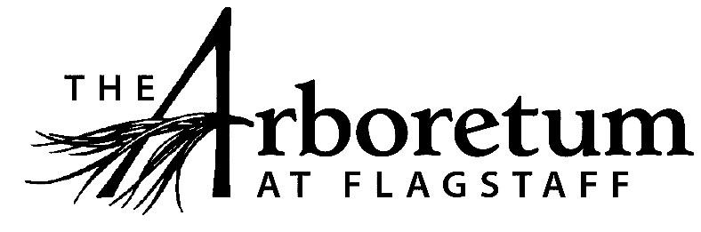

Horticultural Assistant

Classification​
Non-exempt
Reports to
Horticulturist
Date
June 29, 2021
JOB DESCRIPTION
Summary/Objective
This position is primarily responsible for assisting the Horticulturist in the greenhouse and with assigned grounds tasks.
Essential Functions
Reasonable accommodations may be made to enable individuals with disabilities to perform the essential functions.
- Assist Horticulturist in the daily operations of The Arboretum’s greenhouses and shade houses
- Native plant production using asexual and sexual propagation methods
- General greenhouse maintenance and housekeeping, such as pot washing, sweeping, organization, stocking, integrated pest management
- Assist with all plant sales
- Assist with wild seed/plant tissue collections
- Assist with supervision of volunteers and interns
Competencies
- Ability to work independently and as a team member
- Interest/knowledge of native plants of the Colorado Plateau
- Strong verbal and written communication skills
- Ability to prioritize time sensitive tasks
- Dependability
- Flexibility in scheduling
Supervisory Responsibility
This position has no direct staff supervisory responsibilities but does supervise interns and volunteers.
Work Environment
This job operates in a professional office environment, off site venues and outside event areas in various weather conditions. This role routinely uses standard office equipment such as computers, phones, photocopiers, filing cabinets and fax machines.
The Arboretum is located down 3 miles of dirt road that can be wash boarded, muddy, potholed and very challenging during inclement weather and between road grading. Thus, must have reliable transportation. As a public venue that focuses on excellent guest experiences all employees are expected to engage the public in a friendly manner, answer questions, and exhibit professionalism while representing The Arboretum.
Physical Demands
The physical demands described here are representative of those that must be met by an employee to successfully perform the essential functions of this job.
While performing the duties of this job, the employee is regularly required to talk or hear. The employee frequently is required to stand; walk; use hands to finger, handle or feel; and reach with hands and arms. The employee must frequently lift and/or move objects up to 30 pounds and occasionally lift and/or move objects up to 50 pounds.
Position Type and Expected Hours of Work
This is a part time (25 hours per week), seasonal (April-October) position. Days and hours of work vary depending on the needs of the business.
Travel
Travel is primarily local during the business day.
Required Education and Experience
- High school diploma or equivalent
- Growing experience with native plants
Preferred Education and Experience
- Knowledge of multiple plant propagation methods
- Understanding of native plant identification
- Knowledge of IPM tools and techniques
- 1 year of greenhouse experience
Additional Eligibility Qualifications
None required for this position.
Work Authorization/Security Clearance
Must pass background check and hold a valid driver’s license.
AAP/EEO Statement
The Arboretum is an equal opportunity employer committed to applying the principles of applicable state and federal anti-discrimination laws to give equal opportunity for all persons employed or seeking employment without regard to race, age, sex, national origin, religion, color, sexual preference, or disability except in the case of a bona-fide occupational qualification.

In accordance with the applicable law, The Arboretum makes reasonable accommodations for qualified individuals with known disabilities unless doing so would result in an undue hardship. This policy governs all aspects of employment, including selection, job assignment, compensation, discipline, termination and access to benefits and training. The Arboretum operates within the principles of equal employment opportunity guidelines as set forth in applicable federal and state law.
Other Duties
Please note this job description is not designed to cover or contain a comprehensive listing of activities, duties or responsibilities that are required of the employee for this job. Duties, responsibilities and activities may change at any time with or without notice.
Signatures
This job description has been approved by all levels of management:
Manager_______________________________________________
HR____________________________________________________
Employee signature below constitutes employee's understanding of the requirements, essential functions and duties of the position.
Employee____________________​_________ Date_____________

